

American International University-Bangladesh (AIUB)  
**Department of Computer Science  
Faculty of Science &Technology (FST)**

**Fall 19_20**

**Section: J  
Group No:5**

PROJECT TITLE**: ONLINE BANK MANAGEMENT SYSTEM**

***A software Engineering project submitted By***

*MD Arnob Ibna Hasan 17-35690-3 accArnob*

*Priyanka Afreen Hasan 17-34870-2 accAfreen IslamMohaiminul 17-35489-3 mohaiminulsiam*

*Islam Shafiqul 17-35504-3 Sifat-Isalm-sit*

*Fahad Abdullah Al 18-37904-2 no github*

|  |  |
| --- | --- |
| CO3: Choose appropriate software engineering model in a software development environment | Total Marks |
|  |
| Project Background Analysis (needs, goal, benefits, etc.) [5Marks] |  |
| Appropriate Process Model Selection [5Marks] |  |
| Argumentation for model selection with Evidence [5Marks] |  |
| Completeness, Spelling, Grammar and Organization of the Answer [5Marks] |  |
|  | |
| CO4: Explain the roles and their responsibilities in the software project management activities | Total Marks |
|  |
| Content Knowledge (e.g. System Requirements, System Design) [5Marks] |  |
| Project Role identification [5Marks] |  |
| Responsibility Description [5Marks] |  |
| Completeness, Spelling, grammar and Organization of the Answer [5Marks] |  |

contents

1. PROBLEM DOMAIN  **3**

1.1 Background to the Problem 3

1.2 Solution to the Problem 3

2. SOFTWARE DEVELOPMENT LIFE CYCLE **3**

2.1 Process Model  **3**

2.2 Project Roll Identification and Responsibilities  **4**

3. PRODUCT AND PROJECT DESCRIPTION  **4**

3.1 Stakeholders  **4**

3.2 System Features  **4**

4. System Quality Attributes  **4**

4.1 System Architecture  **4**

4.2 System Interface  **5**

4.3 Project Requirements  **5**

**1 PROBLEM DOMAIN:**

**1.1** **BACKGROUND OF THE PROBLEM:**

Banking has been always a highly information intensive activity that relies heavily on information technology (IT) to acquire, and deliver the information to all relevant users. IT is not only critical in the processing information; it provides a way for the banks to differentiate their products and service in the market. Therefore, banks find that they need to constantly innovate and update their information technology to retain their demanding and discerning customers. This is to ensure that they can provide convenient, reliable, and expedient services. Driven by the challenge to expand and capture a larger share of the banking market, some banks invest in more bricks and mortar to enlarge their geographical and market coverage. Others have considered a more revolutionary approach to deliver their banking services via a new medium called as internet. Since the introduction of the internet in 1969, it connection. Creating and managing requirements is a challenge of IT, systems and product development projects or indeed for any activity where you have to manage a contractual relationship. Organization need to effectively define and manage requirements to ensure they are meeting needs of the customer, while proving compliance and staying on the schedule and within budget. The impact of a poorly expressed requirement can bring a business out of compliance or even cause injury or death. Requirements definition and management is an activity that can deliver a high, fast return on investment. The project analyzes the system requirements and then comes up with the requirements specifications. It studies other related systems and then come up with system specifications. The system is then designed in accordance with specifications to satisfy the requirements. The system design is then implemented with MYSQL,JAVA and HTML. The system is designed as an interactive and content management system. The content management system deals with data entry, validation confirm and updating whiles the interactive system deals with system interaction with the administration and users. Thus, above features of this project will save transaction time and therefore increase the efficiency of the system.

**1.2 Solution to the Problem:**

In this growing technology world, internet has not only transformed the lives of people but also has changed the face of banking industry. Banking technology is evolving by the day what is new today will become obsolete tomorrow. Banks and financial institutes are using technology to serve their customers 24x7 by providing them with a platform to help them meet their basic banking requirements. Internet Banking enables banks to provide an easier way to do all the financial transactions through the bank's website. Through our Internet Banking Solution, banks can provide assistance to their customers as per their convenience as they can perform all the banking requirements online. Through the bank's website the customer is able to perform almost their banking requirements on-line, which is why internet banking is also sometimes referred to as online banking or digital banking or virtual banking.

**1.3 Existing / Related Solutions**

Every one use the online banking system .

**2**  **SOFTWARE DEVOLAPMENT LIFE CYCLE**

**2.1 Process Model :**

Agile model:This Project we make by Agile Model.

Within the original Manifesto for Agile Software Development the authors focused on four fundamental, core values that underpin solid software development.

* Individuals and interactions: Rather than solely emphasizing systems and tools, the focus should be on the people within the team and the interactions they have while working together on the project. For a project to be successful, it should adapt to not just the systems or budget available, but most importantly to the people working on it. If team members are efficient and effective at working together, the end result will be a polished and optimized product.
* Working software: While documentation can certainly be very beneficial during development, it is far better to produce a working product, or even a simple prototype, that illustrates the design goals or the components used throughout the application. This is beneficial not only to other team members working on development, management, and marketing, but especially to clients or testers who would otherwise be forced to rely on a handful of documents and photoshopped illustrations to understand how the application is expected to function.
* Customer collaboration: As with online bank management system or any other development model born from the roots of the agile model, it is critical that the project be constantly open, willing, and able to respond to customer feedback and behavior. By keeping customers or clients in the loop throughout the entire life cycle, everyone involved will be on the same page and there will not be any surprises at the end or massive rewrites necessary because a module or integration wasn’t clear for all parties involved.

Responding to change: Perhaps the most critical principle across the entirety of the agile model is the ability for the project to adapt and respond to the ever-changing needs of everyone and everything involved. As development progresses, software technologies will

**2.2 Project Roll Identification and Responsibilitie**

**Agile Master :** Scrum Master interacts with the project team as well as with the customer and the management during the project. Afreen is the agile master.I am seclect the team of this kind of project .

**Product Owner :**MD Arnob Ibna Hasan is a Product owner . Product Owner is officially responsible for the project, managing, controlling, and making visible the Product Backlog list. I am selected by the Scrum Master, the customer, and the management.

He makes the final decisions of the tasks related to product Backlog.

**Agile Team :** MD Fahad Abdullah and MD Sifat Islam is a Agisle Team .they are full fill all the customer reqqurments.Scrum Team is the project team that has the authority to decide on the necessary actions and to organize itself in order to achieve the goals of each Sprint.

The scrum team is involved, for example, in effort estimation, creating the Sprint Backlog, reviewing the product Backlog list and suggesting impediments that need to be removed from the project

**Management :**MD Muhimunul Islam is a manager .he manage all the team

**3.0 PRODUCT AND PROJECT DESCRIPTION**

**3.1 Stakeholders:**

MD:Arnob Ibna Hasan (Product Owner)

Afreen Priyanka(Agile Master)

MD Fahad Abdullah(Agile Team)

MD Sifat Islam(Agile Team)

MD Muhiminul Isalm(Manager)

MD:Arnob Ibna Hasan(code write,Requrments full fill)

Afreen Priyanka(Code Test)

MD Fahad Abdullah(Draw All The Diagram)

MD Sifat Islam(Code Upadte)

MD Muhaiminul Islam(Manage All The Team)

**3.2 System Features**

**1..System Login**

Developed by Md. Jasim Uddin & Nuruzzaman (BCSE/28

th

Batch)

2.1.Modules Description

The Modules description of Bank Account Management System project. These modules will

be developed in PHP source code and MYSQL database.

1. Create New Account: A customer who having the account in the world can create a

virtual account through this module. This module receives the customer profile details

and the bank account details with the proof of the ownership of the bank account.

2. Login: Virtual account holders can login in to the system using this module. Thus this

is the secured login page for the customers in the website.

3. Virtual Account: After the approval of new virtual account creation, the customer

assigned a unique virtual account number to make the online money transactions. This

module views the details of the logged customer's virtual account.

4. Bank Accounts: A customer may have more than one bank account in various banks,

in this case, the customer prompted to decide which bank account should reflect in the

account debit or amount credit. For these operations customers can add their owned

bank accounts here and it will be approved by the administrations of the system.

5. Fund Transfer: This is the module to make fund transfer to the virtual bank account

holders or the usual bank account holders from the customer's specified bank

account.

6. Beneficiary: Beneficiary is a person who receives money. Here the customer can add

the beneficiaries to make fund transfer in the future.

7. Transactions: This module displays the transactions made by the customer in the

particular date with the transaction details.

8. Administrative Control: This module contains the administrative functions such as

view all virtual account, transactions, approve bank accounts, approve virtual

accounts etc.

There

**4.0 System Quality Attributes**

The design phase plays a vital role than all other phases in the software development. Software Architecture has to meet both the functional and non-functional quality requirements. The Evaluation of Architecture has to be performed, so that the developers are assured that their selected Architecture will reduce the cost and effort and also enhances the various quality attributes like Availability, Reusability, Performance, Modifiability and Extendibility. The success of the system depends upon the Architecture Evaluation by the essential method to the system. The overall ranking of the candidate architecture is ascertained by assigning weight to the scenario and scenario interaction. In this paper, SAAM method is taken to evaluate the two architectures from the various available method and techniques to achieve the various quality attributes by weight metric.

**4.1 System Architecture**

**Activaty diagram:**

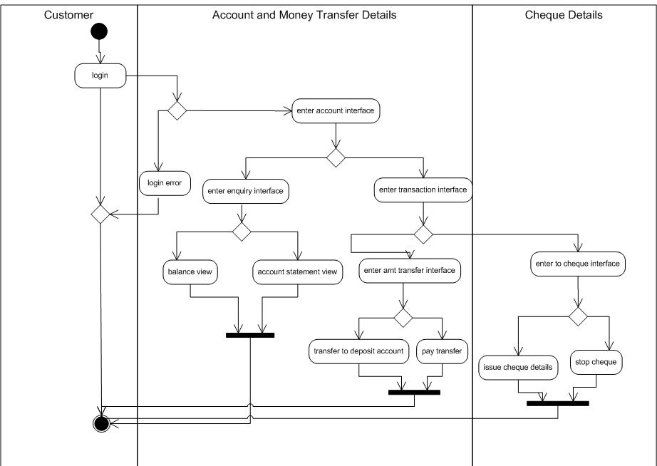

**Use case diagram**

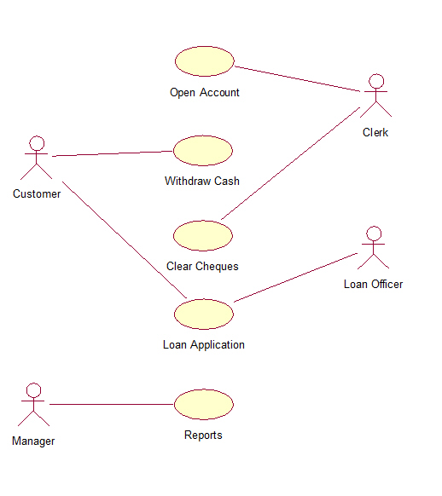

**class diagram**

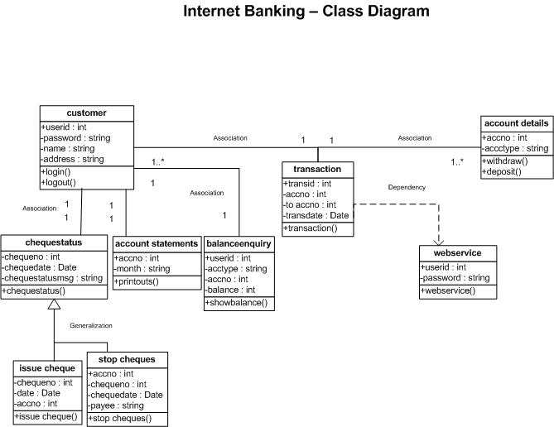

**4.3 Project Requirements:**

## Front End/Language : JAVA

## Back End/Database : MYSQL

## Additional Tools : XAPM Server

## System : Windows